

INFRASTRUCTURE APPLICATION REQUIREMENTS – Werkverkenner

Version: 0.2

Date: 08-12-2023

Document purpose

This requirements document (REQ) is used to:

* Gain a common understanding of the application requirements
* Document the requirements relevant for the DXC Infrastructure Application design (IA HLD)

The document outlines:

* External entities
* Functional and non-functional requirements

Relation to other documents

The following documents may be relevant as context to this REQ:

* The Software Architecture Document (SAD)
* The Project Start Architecture (PSA) document
* Infrastructure Application design produced by DXC for related applications (interfaces)

Structure of the document

High level flow: first the application overview and architecture are described followed by the functional and non-functional requirements that ‘drive’ the solution as it will be described in the DXC HLD.

Content of the document

UWV has prepared this document in good faith and is based on the information gathered during the requirement determination phase with all parties involved; application vendors, UWV architects, developers and UWV functional management.

Table of Contents

1 Application Overview 4

1.1 Introduction 4

1.2 Scope of the desired change 4

1.3 Application use cases 4

1.4 Out of Scope 4

2 Architecture 5

2.1 Conceptual 5

2.2 Context diagram 7

3 Functional Requirements 10

4 Non-Functional Requirements 11

4.1 Security & Compliance classifications 11

4.2 System and Software requirements 12

4.3 Performance requirements 15

4.4 Security requirements 15

4.5 Backup and Recovery 16

4.6 Disaster Recovery 16

Appendix A: Template version control 17

Appendix B: Document version control 19

Appendix C: Legenda 20

Legenda Context Diagram 20

Appendix D: MCPaaS – Capacity allocation details 21

# Application Overview

## Introduction

Werkverkenner 1.0 originates from 2011 and is currently deployed as integrated function within Werk.nl. In the period 2014-2015 several UWV clients have received additional questions which has led to an improved calculation model. This model has been further refined. Werkverkenner 2.0 backend is the implementation of this refined calculation model.

## Scope of the desired change

This changes will require an additional integration (Dutch: koppeling) from KVB to DIM. The exiting integration from KVB to DWH must stay alive.   
  
Functional; the same data sending to DWH must also send to DIM.  
Technical; We must sending data to DIM on the same way as we do to DWH, by using DBlink.

This new integration is to be established in the Production and all Accept environments (including KATO)  
  
Remark: During the fase 2 of the BMS project the integration with DWH will stop. A new HLD requirement document wil be created for this change. So this is out of scpe of this HLD.

## Out of Scope

* The development and test environment are not managed by DXC and are out of scope of this HLD
* All components that belong to the UWV Office Infrastructure such as workstations, web browsers are out of scope.
* The application is developed in the UWV OTOD environment, the only environments in scope for this design are Acceptance and Production.

# Architecture

## Conceptual

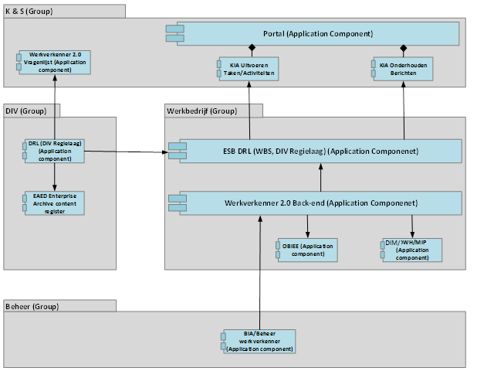

**Key Concepts:**

* Werkverkenner 2.0 backend processes questionnaire and registration data from UWV clients and returns results in the form of scores for re-employability.
* ESB/SOA provides interface with various UWV applications and performs the actual calculations.
* The Werkverkenner 2.0 backend application communicates via the WBSBUS with all other applications.
* OBIEE retrieves the “Werkverkenner” results per customer and determines urgency and other follow-up actions for the customer and/or the employee of “Werkbedrijf”.
* DWH enables users with appropriate authorization on VIEWS to access “Results” and “Questionnaire/Answers”.
* DIM enables users with appropriate authorization on VIEWS to access “Results” and “Questionnaire/Answers”.
* Werkverkenner Beheer change/update application and business reference data, formulas and “Questionnaire: Practical Tips” in Werkverkenner 2.0.

## Context Diagram

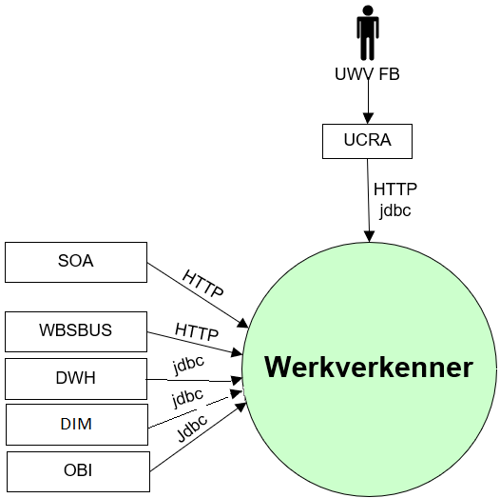

### External entities

#### UWV FB

|  |  |
| --- | --- |
| **Description** | UWV FB, Functionality to change/update Application and business reference data, formulas and “Vragenlijst: Praktische Tips” in Werkverkenner 2.0 |
| **Protocol and Port** | HTTP (8080), jdbc (1526) |
| **DC (Datacenter) connection** | Internal |
| **Direction** | Inbound |
| **Direct connection** | No, via UCRA |
| **Security Controls** | Not specified |
| **Number of users** | Not specified |
| **Number of transactions** | Not specified |
| **Frequency of transactions** | Not specified |
| **Volume of data** | Not specified |

#### SOA

|  |  |
| --- | --- |
| **Description** | Provides two functions to Werkverkenner   * interfaces with various UWV applications * Performs the actual calculations (“rekenmodule”) on behalf of Werkverkenner |
| **Protocol and Port** | HTTP (8080) |
| **DC (Datacenter) connection** | Internal |
| **Direction** | Inbound |
| **Direct connection** | yes |
| **Security Controls** | The connection from the SOA (Werk.nl) is protected by a system-to-system account. |
| **Number of users** | Not specified |
| **Number of transactions** | 350.000 questionnaires processed per year |
| **Frequency of transactions** | 1000 questionnaires processed per day |
| **Volume of data** | Not specified |

#### WBSBUS

|  |  |
| --- | --- |
| **Description** | DRL_SCORES_ Werkverkenner   * uwv.nl-drl-WBSBUS-WVK M-WVK BE |
| **Protocol and Port** | HTTP (8080) |
| **DC (Datacenter) connection** | Internal |
| **Direction** | Inbound |
| **Direct connection** | yes |
| **Security Controls** | Not specified |
| **Number of users** | Not specified |
| **Number of transactions** | 350.000 questionnaires processed per year |
| **Frequency of transactions** | 1000 questionnaires processed per day |
| **Volume of data** | Not specified |

#### DWH

|  |  |
| --- | --- |
| **Description** | Enables users with appropriate authorization on VIEWS to access “Resultaten” and “Vragenlijst/Antwoorden” |
| **Protocol and Port** | jdbc (1526) |
| **DC (Datacenter) connection** | Internal |
| **Direction** | Inbound |
| **Direct connection** | yes |
| **Security Controls** | This is considered as Applications links. Control done on the application |
| **Number of users** | Not specified |
| **Number of transactions** | 350.000 questionnaires processed per year |
| **Frequency of transactions** | 1000 questionnaires processed per day |
| **Volume of data** | Not specified |

#### DIM

|  |  |
| --- | --- |
| **Description** | Enables users with appropriate authorization on VIEWS to access “Resultaten” and “Vragenlijst/Antwoorden” |
| **Protocol and Port** | jdbc (1526) ??? |
| **DC (Datacenter) connection** | Internal |
| **Direction** | Inbound |
| **Direct connection** | yes |
| **Security Controls** | This is considered as Applications links. Control done on the application |
| **Number of users** | Not specified |
| **Number of transactions** | 350.000 questionnaires processed per year |
| **Frequency of transactions** | 1000 questionnaires processed per day |
| **Volume of data** | Not specified |

#### OBI

|  |  |
| --- | --- |
| **Description** | OBI (Business analytical function) retrieves the “Werkverkenner” results per customer and determines urgency and other follow-up actions for the customer and/or the employee of “Werkbedrijf”. |
| **Protocol and Port** | jdbc (1526) |
| **DC (Datacenter) connection** | Internal |
| **Direction** | Inbound |
| **Direct connection** | yes |
| **Security Controls** | This is considered as Applications links. Control done on the application |
| **Number of users** | Not specified |
| **Number of transactions** | 350.000 questionnaires processed per year |
| **Frequency of transactions** | 1000 questionnaires processed per day |
| **Volume of data** | Not specified |

# Functional Requirements

No functional requirements have been specified.

# Non-Functional Requirements

## Security & Compliance classifications

Repository used is: “2022 UWV-brede Risico Applicatie Lijst v1.0”

The BIV rating (confidentiality) will result in chosing the UWV data appropriate zoning principals.

requirements applicable.

|  |  |
| --- | --- |
| **Application** | Werkverkenner |
| **Owner** | WB |
| **Availability (Beschikbaarheid)** | 3 |
| **Integrity (Integriteit)** | 2 |
| **Confidentiality (Vertrouwelijkheid)** | 2 |
| **Type of information /Data Classification** | Customer Personal data |
| **Direct or Indirect part of the primary information chain** | Direct |

Note: The BIV rating in the “*2020 UWV-brede Risico Applicatie Lijst v1.0*” differs (2, 2, 2+).

### Risk Analysis UWV

No risk analysis provided by UWV.

### Applicable security and compliance frameworks

|  |  |
| --- | --- |
| Security & Compliance Framework | Applicable |
| BIR 2017 | Yes |
| AVG / GDPR | Yes |
| DIGID | No |
| SUWI | No |
| Additional frameworks | Not specified |

## Capacity and Performance (Volumetrics)

### Werkverkenner 2.0 – Server capacity

The initial capacity is based on the standard UWV Linux Application server deployment. Performance tests after setting up the server Acceptance environment should indicate whether the infrastructure must be up- or downscaled.

The application will be deployed on dedicated virtual server, the following server capacity is required:

* Production: 1 CPU with 4 GB memory
* Acceptance: 1 CPU with 4 GB memory

See Appendix A for details.

## Availability

|  |  |  |  |  |
| --- | --- | --- | --- | --- |
| **Environment** | **Application Target** | **Application Service Hours** | **Infra Target** | **Infra Service Hours** |
| Production | 98% | 5 x 12 (Mo-Fr, 7-19h) | 98 % | 5 x 12 (Mo-Fr, 7-19h) |
| Acceptance | 98% | 5 x 12 (Mo-Fr, 7-19h) | 98% | 5 x 12 (Mo-Fr, 7-19h) |

## Security requirements

Access to the tooling must be restricted to authenticated and authorized users using the standard authentication and authorization mechanism.

### Access Management

Security with regards to interactive usage:

* The Werkverkenner 2.0 backend can/will only be triggered from authorized sessions in matter specific systems.
* The only exception to the rule above is the interactive execution of scripts to update/change the formulas and calculations of Werkverkenner 2.0. This requires role-based access to the application folders only and will be executed by DXC TAB.

Security with regards to usage of webservices-processing:

* No specific security requirements.

### Transactional traceability

Transactional traceability can only apply to the Werkverkenner indirectly:

* All external interfaces can be considered application/application links, which implies only derived authorizations can exist.
* Traceability of the scripts to update/change the Werkverkenner 2.0 formulas will need to be done through change management.

Detailed Security requirements are documented in Appendix D.

## System management

No specific system management requirements.

## Backup and Recovery

No specific backup requirements.

## Storage replication

|  |  |
| --- | --- |
| **Environment / System** | **Storage Replication** |
| Production | Yes |
| Acceptance | No |

## Scalability

The solution must be vertical scalable, Werkverkenner 2.0 BE application software determines how well the application scales.

## Disaster Recovery

No specific disaster recovery requirements.

## Technical Constraints

No technical constraints identified.

## DXC TAB requirements

|  |  |
| --- | --- |
| **Category** | **Description** |
| Deployment | * HTTP (8080) connection from Werk.nl TAB deployment to the Werkverkenner application server is required * jdbc (1526) connection from Werk.nl TAB deployment to the Werkverkenner database server is required * SSH (22) connection from XLdeploy to Werkverkenner application server is required |
| Other TAB applicable requirement | * HTTP (80, 8080) connection from Sitescope to the Werkverkenner application server is required for application monitoring |

# Appendix A: Template version control

**TEMPLATE CHANGE HISTORY**

|  |  |  |
| --- | --- | --- |
| Version | Date | Summary of Changes |
| 0.1 | 08-07-2022 | * Initial version UWV requirements template, ready for review |
| 0.2 | 13-07-2022 | * Included review comments Giuliana to prepare for follow-up meeting |
| 0.3 | 14-07-2022 | * Included review comments Giuliana and Henk-Jan to prepare for REQ template pilot |
| 0.8 | 14-07-2022 | * Cora marked the REQ template v0.8.  Prepared for final UWV review and the additional writer’s instruction from Thomas H, Remco H and Walter |
| 0.9 | 25-07-2022 | * Pre-pilot version |
| 0.91 | 27-07-2022 | * Split Appendix A in A and B for document control |
| 0.92 | 11-08-2022 | * improved instructions after 1st workshop with IO&R hosting team and evaluation of pilot (use case: edit HLD for existing application) |
| 0.93 | 24-08-2022 | * improved instructions after 2nd workshop with IO&R hosting team |
| 0.99 | 28-10-2022 | * Improved and added instructions by Henk-Jan after evaluation of first use in production and to finalize template to v1.0 |
| 1.0 | 11-01-2022 | Finalized with the following adjustments   * Updated 4.4 includes service level and service hours * Updated 4.8 Added note for AIX Bronze systems |
| 1.1 | 02-01-2023 | * Updated instructions for certificate selection |
| 1.2 | 23-02-2023 | Updated the template with MCPaaS (Managed Container Platform as a Service) specific requirements   * Removed Chapter 3 (functional requirements), Evaluation shows that this is either not filled or when it is filled the requirements are non-funtional. Functional requirements for the application are documented in the application design (SAD) * Moved chapter 4.8 (storage replication) under 3.2.1 to bundle the Private Cloud (build)requirements together * Moved chapter 4.4 (Availibility), 4.6 (System management) and 4.10 (TAB requirements) under 3.2.1 and 3.2.2 to bundle the Private Cloud system and Container application requirements together * Moved chapter under 3.2.1 and 3.2.2 to bundle the Private Cloud system and Container application requirements together * Updated 4.2 System and Software requirements: seperate section for Private Cloud and MCPaaS * Updated 4.4 Availability: seperate section for Private Cloud and MCPaaS * 4.6.1 – added addition MCPaaS related infra requirement: Can the standard azure container registry be used by the MCPaaS application |
| 1.21 |  | Added Chapter 3 again: Functional requirements, to keep all chapter the same also for old documentation and to have the possibility to document functional requirements that might seem relevant  Updated 4.2.1.5 System management   * Added load balancer requirements * Added known application scalability limitations |

# Appendix B: Document version control

**USED TEMPLATE**

|  |
| --- |
| Based on REQ Template: UWV REQ – TEMPLATE 1.2.docx |

**CHANGE HISTORY**

|  |  |  |  |
| --- | --- | --- | --- |
| Version | Date | Author | Summary of Changes |
|  |  |  |  |
|  |  |  |  |
|  |  |  |  |
|  |  |  |  |
|  |  |  |  |
|  |  |  |  |

# Appendix C: Legenda

## Legenda Context Diagram

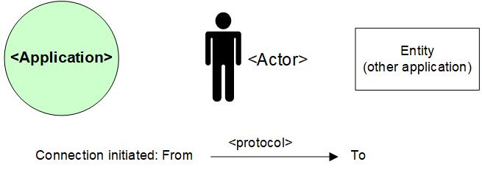

# Appendix D: MCPaaS – Capacity allocation details

**EXAMPLE**

**Capacity allocation for <CompetentNL>**

To manage the resource allocation and assure the project uses only appropriate or agreed resources on the cluster, the quotas and limits to compute resources for the CompetentNL projects on the MCPaaS will be based on below details.

|  |  |  |  |  |  |  |
| --- | --- | --- | --- | --- | --- | --- |
| **Service (pod)** | **Mem Reservation** | **Mem Limit** | **CPU Reservation** | **CPU Limit** | **Scale - nr of containers (Development)** | **Scale - nr of containers (Test)** |
| CNL-Backend | 256M | 512M | 0,1 | 0,3 | 1 | 1 |
| CNL-Frontend | 128M | 256M | 0,1 | 0,5 | 1 | 1 |
| CNL-IAM | 256M | 512M | 0,1 | 0.5 | 1 | 1 |
| CNL-Dataloader | 256M | 512M | 0,1 | 0,2 | 1 | 1 |
| CNL ActiveMQ | 256M | 512M | 0,1 | 0,3 | 1 | 1 |
| CNL-Config-server | 128M | 256M | 0,1 | 0,2 | 1 | 1 |
| CNL-api | 256M | 512M | 0,1 | 0,5 | 1 | 1 |
| CNL-Synchronization | 128M | 256M | 0,1 | 0,3 | 1 | 1 |
| CNL-DB Management | 128M | 256M | 0,1 | 0,2 | 1 | 1 |
| CNL-Search | 1024M | 3072M | 0,1 | 1 | 1 | 1 |

*Total Required resource allocation*

*Note: Required resource allocation for Development and Test is an initial estimation. After initial tests on these environments resource allocation for all environments will be finalized and updated. Besides the resource allocation for Acceptance and Production are based on the experiences from Development and Test.*

|  |  |  |  |  |
| --- | --- | --- | --- | --- |
| **Size description** | **Development** | **Test** | **Acceptance** | **Production** |
| Mem minimum run | 2816M | 2816M | TBD | |
| Mem maximum run | 6656M | 6656M |
| CPU reservations | 1 | 1 |
| CPU reservations limit | 4 | 4 |